TITLE: | Generative AI Use Policy
ISSUED BY: | County Administrator
RESPONSIBLE STAFF: | Department of Technology Services
ISSUE DATE: | 02/24 | REVISION DATE:
PURPOSE: | This Generative AI Use Policy establishes clear guidelines for the ethical, secure, and responsible use of generative AI technologies within Calvert County Government (CCG). The policy aims to enable innovation while safeguarding data integrity, privacy, and transparency in alignment with CCG’s standards and values.
APPLICABLE TO: | All Calvert County Government Employees
ATTACHMENTS:

GUIDELINE | POLICY | PROCEDURE
This document needs to be reviewed/updated:
Annually  (Fiscal Year)  (Calendar Year) | Other Interval:
Annually  (Fiscal Year)  (Calendar Year) | As needed | Flag for review on:

PURPOSE
This Generative AI Use Policy establishes guidelines for the responsible and ethical use of Generative Artificial Intelligence (AI) technologies within Calvert County Government (CCG). To ensure the integrity, security, and appropriate utilization of AI technologies, all Generative AI (GenAI) applications, tools, or systems must receive prior approval from the established AI Committee. The AI Committee is responsible for assessing the potential risks, benefits, and ethical considerations associated with the deployment of GenAI technologies to maintain compliance with CCG's standards and values.

SCOPE
This Generative AI Use policy applies to all Authorized Users, including temporary and contract staff, of CCG.

This policy will be revised and amended, as necessary.

DEFINITIONS

Artificial Intelligence (AI)
The ability of a digital computer or computer-controlled robot to perform tasks commonly associated with intelligent beings. AI systems can perform tasks such as learning, reasoning, planning, perception, and problem-solving.

AI Committee
A group of organizational representatives tasked with evaluating and advising the rest of CCG on the effectiveness and safety of AI technology use. The committee is composed of one delegate from each of the following: the County Administrator’s Office, the County Attorney’s Office, the Department of Human Resources, the Department of Communications and Media Relations, and the Department of Technology Services, including a technical lead from the Department of Technology Services.

Authorized Users
CCG employees, personnel under CCG contracts, volunteers, and all other approved individuals using information technology resources.

Authorized Supervisory Personnel
Any personnel to whom Authorized Users directly report.

Confidential Data
Data that must not be disclosed to unauthorized individuals due to legal, contractual, or business obligations, where disclosure may result in financial or reputational damage to CCG.

Restricted Data
Data that requires the highest level of protection due to legal penalties if mishandled.

Chief Information Security Officer (CISO)
Oversees the Cybersecurity Team and serves as the head of developing and enforcing cybersecurity strategies, frameworks, and policies to protect the continuity of CCG’s data and information technology systems.

Generative AI (GenAI)
Refers to a class of artificial intelligence-driven computer technology that generates new content, including text, images, audio, and video, in response to user prompts.

Human in the Loop (HITL)
A GenAI reviewal process model which requires a human being to aid the GenAI system in creating the most accurate and valuable outputs possible.

Internal Data
Information created or bestowed upon CCG by partners or clients on mutual trust which shall be kept within CCG to protect business interests and continued client trust. If disclosed to the public, it can cause harm to citizens’ and partners’ business interests.

Large Language Model (LLM)
A type of AI trained on vast amounts of text to generate natural-sounding language. For example, chatbots or virtual assistants that can answer questions.

Public Data
Data that is freely available and accessible to the public, without the need for tracking or monitoring. However, authorized users shall still adhere to legal requirements and organizational policies in handling, using, and distributing this data.

Retrieval Augmented Generation (RAG)
An AI approach that enhances response accuracy by pulling relevant information from a specified database, ensuring users receive dependable, knowledge-based answers.

POLICY STATEMENT
CCG acknowledges employees utilize GenAI, which brings risks associated with it including the potential for inadvertent exportation of Confidential and Restricted Data, and the publication of inaccurate or misleading information. This policy establishes clear guidelines to prevent unauthorized data sharing and to ensure the accuracy and reliability of information disseminated to the public. All GenAI technologies and applications used shall comply with relevant laws and regulations. No employee shall input restricted data into GenAI unless authorized encryption mechanisms are in place.

AUTHORIZATION
Authorized Users may use GenAI technologies which have undergone a two-step approval process. Initially, the AI Committee must approve the use of any GenAI tool to ensure security and effectiveness. Subsequently, Department Heads and Division Chiefs are responsible for granting further authorization. This crucial step involves assessing the specific use of the AI tool within their department, considering its effectiveness, security, and compatibility with departmental tasks, especially those involving sensitive data or public interaction. This process ensures a deliberate and informed application of GenAI technologies in line with the county's operational integrity and ethical standards.

SELECTION CRITERIA
When engaging with GenAI technologies, Authorized Users must ensure these technologies are in full compliance with all CCG policies. In addition, the selected GenAI technology must facilitate the exportation of any CCG-relevant data, adhering to a minimum 30-day retention period.

Authorized Users must understand and accept that any data provided to GenAI which is not within the CCG environment may become part of the model's integrated data set. Therefore, AI technology shall either provide capability to purge data as necessary or ensure data is securely contained within a restricted environment.

RETRIEVAL AUGMENTED GENERATION
Retrieval Augmented Generation (RAG) is a specialized AI that differs from GenAI by focusing on specific, relevant information sources for generating responses. Unlike GenAI, which pulls data from a wide array of general sources, RAG uses targeted, up-to-date information from specific databases, making it highly effective for tasks like service delivery and accessing internal knowledge.
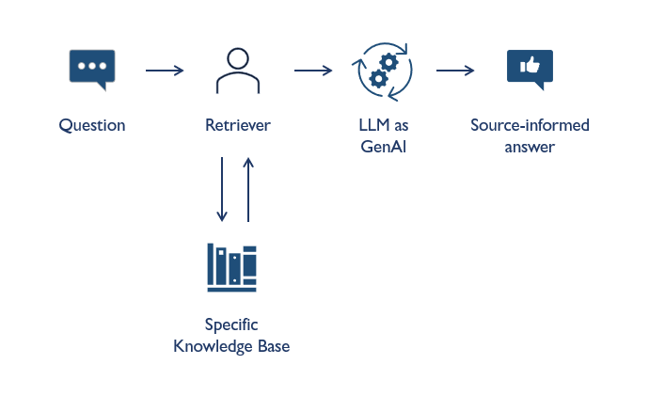
CCG may employ RAG AI technology to serve as a secure and reliable tool for ensuring effective customer service, efficient internal operations, and supporting informed decision-making.

RISK

Risk Matrix of Generative AI Use
The risk assessment model for GenAI use categorizes activities based on the level of risk it poses into three risk groups: Mid Risk, High Risk, and Prohibited. The model serves as a guide to prevent information breaches and manage the impact of GenAI technologies.
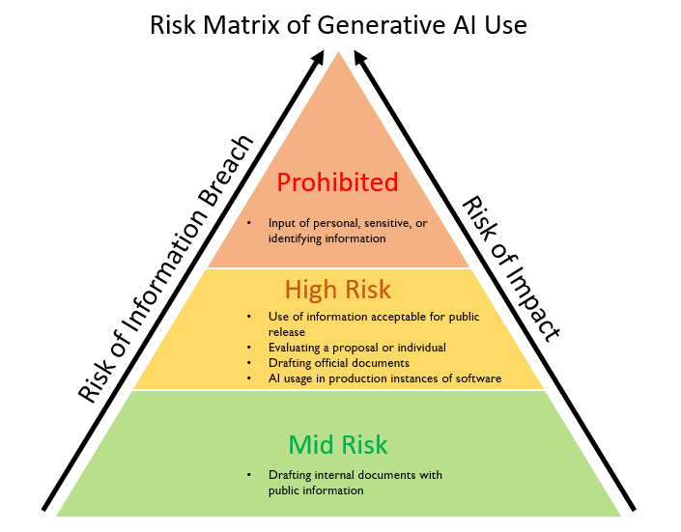

USAGE GUIDELINES

Accuracy
Authorized Users shall ensure GenAI outputs are accurate, unbiased, and do not compromise the integrity or reputation of CCG. All outputs shall undergo human review, following Human in the Loop (HITL) procedures by the responsible departments to ensure compliance with this document's principles. Documentation of HITL review shall be retained according to Records Management retention schedules. Regardless of whether AI is used to accomplish any task, the Authorized User remains accountable for the final work product. Reliance on AI is not an acceptable basis for incomplete, inaccurate, inappropriate, incorrect, or other defective work products.

Attribution
Authorized Users shall clearly cite the use of GenAI when GenAI is solely responsible for the creation of a final product.

Images, videos, and audio created by GenAI systems shall be attributed to the GenAI technology used. Wherever possible, attributions and citations to Calvert County shall be embedded in the image or video (e.g., via digital crest/watermark).

All attributions shall include the name of the AI system used plus an HITL assertion (which shall include the department or group that reviewed/edited the content).
Example: Some material in this brochure was generated using ChatGPT 4.0 and was reviewed for accuracy by a member of the Department of Human Resources before publication.

Property Rights
Authorized Users shall respect intellectual property rights and ensure generated content does not infringe on copyrights.

Confidential Information
Authorized Users shall not input personal, sensitive, confidential, or restricted information into GenAI systems.

Prohibited Uses
GenAI shall not be used to create misleading information, impersonate, or engage in any illegal activities.

Review and Fact-Check
Authorized Users shall review and fact-check all GenAI outputs.

For more specific usage details, please reference the TS ChatGPT Usage Guide.

DATA SECURITY AND PRIVACY
Authorized users shall adhere to the CCG Data Classification Policy when using GenAI technologies. Users shall exercise caution when importing information into GenAI to prevent the inadvertent sharing of personal or sensitive data.

VIOLATIONS
Any Authorized User found in violation of this policy may be subject to disciplinary action, up to and including termination of employment, under County Code Chapter 86, Part 9, Disciplinary Action. Employee recourse to such actions is outlined in Part 10, Grievance Procedure.

The Board of County Commissioners of Calvert County reserves the right to advise appropriate legal officials of any policy violation and, where appropriate, institute legal proceedings against violators.

Misuse of data may require financial restitution to the County for funds expended and could result in civil or criminal action. It is the responsibility of all users to report any suspected or actual violations of this policy to the AI Committee. Failure to report a suspected or actual violation may also result in disciplinary action.

ROLES AND RESPONSIBILITIES

All Authorized Users are responsible for:
- Accountability for the accuracy and compliance of outputs from GenAI systems;
- Awareness of and following the requirements of this policy;
- Understanding what constitutes misuse of GenAI as prescribed by this policy;
- Protecting sensitive, confidential, and restricted information from insertion into GenAI; and
- Reporting suspected unauthorized use or misuse of GenAI to Authorized Supervisory Personnel.

All Authorized Supervisory Personnel are responsible for:
- Monitoring and documenting use cases for GenAI;
- Ensuring subordinates are aware of this policy;
- Alertness to possible misuse of GenAI;
- Submitting written substantiation of possible misuse of GenAI to the AI Committee, through appropriate supervisory personnel;
- Responding as appropriate to possible misuse of GenAI as identified by the AI Committee;
- Working in consultation with the Director of Human Resources and the County Attorney to determine whether misuse of GenAI has occurred and the appropriate disciplinary action; and
- Notifying the Department of Technology Services when an authorized user will be terminating County employment. This notification shall be made prior to the actual departure of the employee.

The AI Committee is responsible for:
- Monitoring the safety and effectiveness of GenAI,
- Responding to allegations of misuse of GenAI;
- Authorizing system administrators to carry out appropriate investigative actions;
- Providing the results of investigative actions to Authorized Supervisory Personnel; and
- Responding to any disciplinary actions which require changes in the access privileges of Authorized Users.

The County Attorney is responsible for advising the AI Committee on:
- Whether the substantiation of possible misuse is adequate to justify an investigation;
- The appropriate investigative methods to be used;
- Whether the individual's consent shall be sought prior to any inspection of the individual's GenAI accounts; and
- The Authorized Supervisory Personnel who shall review the investigative results.

The Human Resources Director is responsible for:
- Working in coordination with Authorized Supervisory Personnel and/or the County Attorney to determine appropriate disciplinary actions in response to abuses of these services.

Chief Information Security Officer (CISO) is responsible for:
- Overseeing the security, compliance, and risk management aspects of GenAI technologies;
- Ensuring all GenAI tools and applications comply with CCG’s Data Classification Policy and applicable data privacy regulations.
- Implementing and monitoring security controls to protect Confidential and Restricted data when using GenAI technologies.
- Collaborating with the AI Committee to establish safeguards that prevent unauthorized data sharing or exposure through GenAI systems.
- Leading risk assessments for GenAI implementations, identifying potential vulnerabilities, including data leakage, unauthorized access, and system exploitation.
- Developing and maintaining a risk matrix that classifies GenAI activities into Mid Risk, High Risk, and Prohibited categories, and implement appropriate security measures to mitigate risks.
- Overseeing the response to any security incidents or breaches involving GenAI tools, ensuring rapid implementation of incident response protocols.
- Conducting investigations into any misuse of GenAI systems, collaborating with the AI Committee and relevant departments to assess the scope of the breach and recommend corrective actions.
- Performing regular audits of GenAI systems to ensure compliance with CCG’s cybersecurity policies, data protection laws, and other applicable regulations.
- Ensuring GenAI tools adhere to data retention policies, particularly when they involve sensitive or restricted information, and maintain control over any external data handling.
- Ensuring third-party GenAI vendors meet CCG’s security standards by conducting security assessments prior to any deployment of external tools.
- Working with vendors to ensure data purging capabilities and adherence to CCG’s data security protocols, especially for sensitive or restricted data.
- Reviewing and approve all GenAI platforms and use cases to ensure they meet CCG’s security and compliance standards before submission to the AI Committee for final evaluation and authorization.

